1.Taint a Node and Schedule a Tolerant Pod Taint a node with special=true:NoSchedule. Create a pod with a toleration that matches the taint, allowing it to be scheduled on the tainted node.

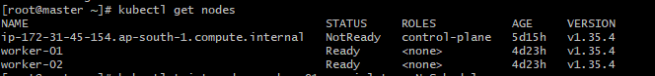
- Taint the node
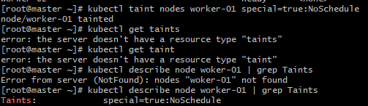

- Create a Pod with matching toleration
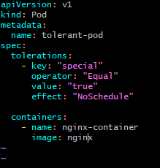

- Deploy the pod
Kubectl apply -f tolerant.yaml
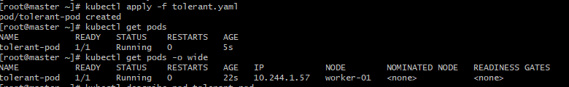
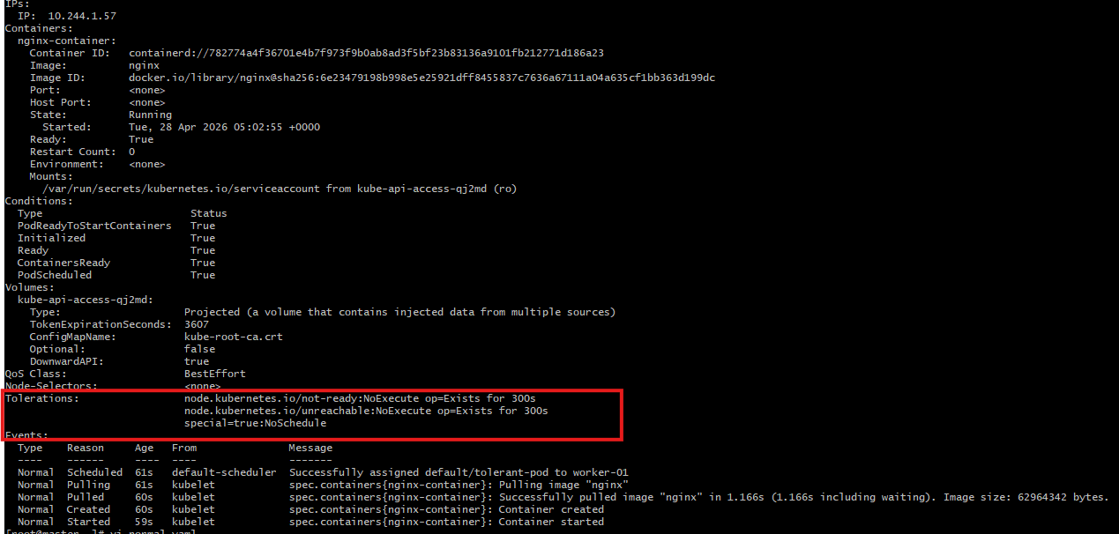

- Test with normal Pod
Vi normal.yaml
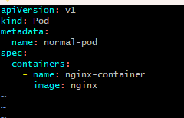

- Deploy the pod
Kubectl apply -f normal.yaml
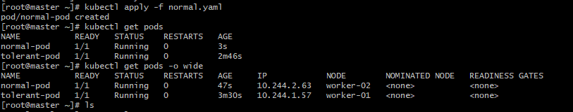

2.Use NodeSelector to Schedule a Pod on a Specific Node Label a node with env=dev. Create a pod with a nodeSelector that schedules it only on the node labeled env=dev.
Steps:
- Label the node

Kubectl label nodes worker-02 env=dev

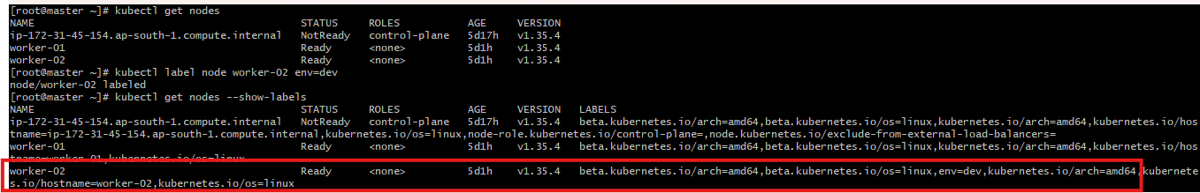

- Create Pod YAML with nodeSelector
Vi nodeselector.yaml
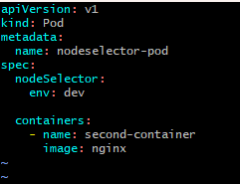

- Deploy the Pod
Kubectl apply -f nodeselector.yaml
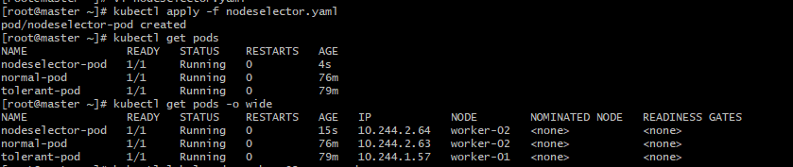

3. Use Node Affinity with Soft Scheduling Label a node with env=test. Create a pod with PreferredDuringSchedulingIgnoredDuringExecution node affinity, preferring to schedule it on a node labeled env=test. Remove the label and verify the pod continues to run.

Steps:
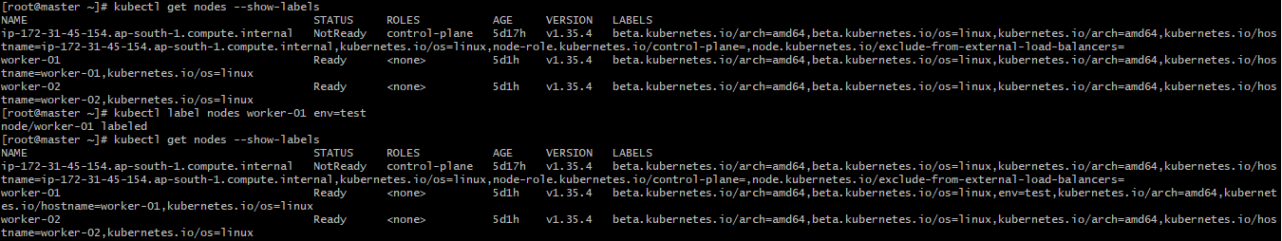
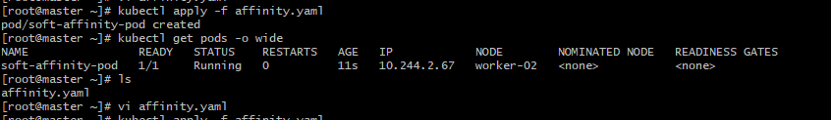

4. Implement Node Affinity with Hard Scheduling Create a pod with RequiredDuringSchedulingIgnoredDuringExecution node affinity, ensuring it will only be scheduled on a node labeled env=prod. Verify the pod cannot be scheduled if no node has the env=prod label.

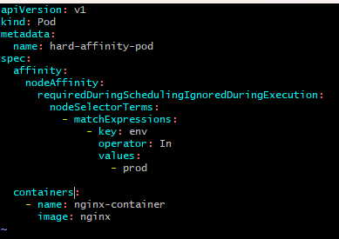
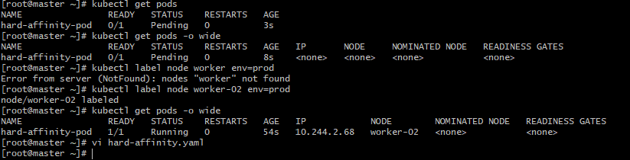

5. Taint a Node and Use NoExecute with Toleration Seconds Taint a node with special=true:NoExecute. Create a pod with a tolerationSeconds field (e.g., 60 seconds) and observe it gets evicted after 60 seconds on the tainted node.
